**ASP.NET - Server Controls**

Controls are small building blocks of the graphical user interface, which include text boxes, buttons, check boxes, list boxes, labels, and numerous other tools. Using these tools, the users can enter data, make selections and indicate their preferences.

Controls are also used for structural jobs, like validation, data access, security, creating master pages, and data manipulation.

ASP.NET server controls are the primary controls used in ASP.NET.These controls can be grouped into the following categories:

**Validation controls** - These are used to validate user input and they work by running client-side script.

**Data source controls** - These controls provides data binding to different data sources.

**Data view controls** - These are various lists and tables, which can bind to data from data sources for displaying.

**Personalization controls** - These are used for personalization of a page according to the user preferences, based on user information.

**Login and security controls** - These controls provide user authentication.

**Master pages** - These controls provide consistent layout and interface throughout the application.

**Navigation controls** - These controls help in navigation. For example, menus, tree view etc.

**Rich controls** - These controls implement special features. For example, AdRotator, FileUpload, and Calendar control.

**STANDARD WEB CONTROLS**

Label control

A label is a [graphical control element](https://en.wikipedia.org/wiki/Graphical_control_element) which displays text on a form. It is usually a static control; having no interactivity. A label is generally used to identify a nearby [text box](https://en.wikipedia.org/wiki/Text_box).

<asp:Label ID="Label1" runat="server" Text="Label"></asp:Label>

Literal control

The Literal Control is similar to the Label Control as they both are used to display static text on a web page.

<asp:Literal ID="Literal1" runat="server">It is a Literal Control</asp:Literal>

Text Box Control

It is used to collect information from a user. It is an input control which is used to input the data.

Button Controls

There are three types of button control available in ASP.NET:

Button

Link Button

Image Button

Button control post backs the web page to web server, when user clicks the button. A Button control can be used as a submit button (default) or a command button.

CheckBox Control

A CheckBox control is used to select a single or multiple options from the available choices. For example a person can select more than one cities for travelling.

PANEL CONTROL

It **c**ontrols the appearance and visibility of the control**s** it contains. It also allows generating controlprogrammatically

**SOURCE CODE**

<%@ Page Language="C#" AutoEventWireup="true" CodeFile="login.aspx.cs" Inherits="_Default" %>

<!DOCTYPE html PUBLIC "-//W3C//DTD XHTML 1.0 Transitional//EN" "http://www.w3.org/TR/xhtml1/DTD/xhtml1-transitional.dtd">

<html xmlns="http://www.w3.org/1999/xhtml">

<head runat="server">

<title></title>

<style type="text/css">

.style1

{

width: 95%;

}

.style5

{

width: 356px;

}

.style9

{

width: 409px;

}

.style10

{

width: 340px;

}

</style>

</head>

<body style="height: 584px">

<form id="form1" runat="server">

<div style="width: 100px; margin: 10px auto;">

<asp:Image ID="Image1" runat="server"

DescriptionUrl="~/Images/download (2).png" Height="100px"

ImageUrl="~/Images/download (2).png" Width="100px" />

</div>

<div style="text-align:center">

&nbsp;

<asp:Label ID="Label1" runat="server" Text="LOGIN FORM" Font-Bold="True"

Font-Size="XX-Large" ForeColor="#0033CC"></asp:Label>

</div>

<div style="width:741px; margin: 10px auto;">

<h1 style="text-align:center">Login as :

<asp:DropDownList ID="DropDownList1" runat="server" Height="24px"

onselectedindexchanged="DropDownList1_SelectedIndexChanged"

style="margin-top: 0px" Width="269px" AutoPostBack="True">

<asp:ListItem Value="0">Select</asp:ListItem>

<asp:ListItem Value="1">Student</asp:ListItem>

<asp:ListItem Value="2">Teacher</asp:ListItem>

</asp:DropDownList>

</h1>

<p>&nbsp;</p>

<asp:Panel ID="Panel1" runat="server" Width="734px">

<table class="style1">

<tr>

<td class="style10">

<asp:Label ID="Label2" runat="server" Text="Name"></asp:Label>

</td>

<td>

<asp:TextBox ID="TextBox15" runat="server" Width="337px"></asp:TextBox>

</td>

</tr>

<tr>

<td class="style10">

<asp:Label ID="Label3" runat="server" Text="Roll Number"></asp:Label>

</td>

<td>

<asp:TextBox ID="TextBox14" runat="server" Width="337px"></asp:TextBox>

</td>

</tr>

<tr>

<td class="style10">

<asp:Label ID="Label4" runat="server" Text="Department"></asp:Label>

</td>

<td>

<asp:TextBox ID="TextBox13" runat="server" Width="337px"></asp:TextBox>

</td>

</tr>

<tr>

<td class="style10">

<asp:Label ID="Label5" runat="server" Text="Degree and Year of study"></asp:Label>

</td>

<td>

<asp:TextBox ID="TextBox12" runat="server" Width="337px"></asp:TextBox>

</td>

</tr>

<tr>

<td class="style10">

<asp:Label ID="Label11" runat="server" Text="Gender"></asp:Label>

</td>

<td>

<asp:RadioButton ID="RadioButton1" runat="server" Text="Male" />

&nbsp;&nbsp;&nbsp;

<asp:RadioButton ID="RadioButton2" runat="server" Text="Female" />

&nbsp;&nbsp;&nbsp;

<asp:RadioButton ID="RadioButton3" runat="server" Text="Others" />

</td>

</tr>

</table>

<asp:CheckBox ID="CheckBox1" runat="server" Text="Subscribe To Newsletter" />

<br />

&nbsp;&nbsp;

<asp:Button ID="Button1" runat="server" Text="Submit"

style="margin-left: 148px; margin-top: 0px;" Width="278px"

BackColor="#99CCFF" Height="35px" PostBackUrl="~/student.aspx" />

</asp:Panel>

<asp:Panel ID="Panel2" runat="server" Width="734px">

<table class="style1">

<tr>

<td class="style9">

<asp:Label ID="Label6" runat="server" Text="Name"></asp:Label>

</td>

<td class="style5">

<asp:TextBox ID="TextBox5" runat="server" Width="337px"></asp:TextBox>

</td>

</tr>

<tr>

<td class="style9">

<asp:Label ID="Label7" runat="server" Text="Department"></asp:Label>

</td>

<td class="style5">

<asp:TextBox ID="TextBox9" runat="server" Width="337px"></asp:TextBox>

</td>

</tr>

<tr>

<td class="style9">

<asp:Label ID="Label8" runat="server" Text="Gender"></asp:Label>

</td>

<td class="style5">

<asp:RadioButton ID="RadioButton4" runat="server" Text="Male" />

&nbsp;&nbsp;&nbsp;&nbsp;&nbsp;

<asp:RadioButton ID="RadioButton5" runat="server" Text="Female" />

&nbsp;&nbsp;&nbsp;&nbsp;&nbsp;

<asp:RadioButton ID="RadioButton6" runat="server" Text="Others" />

</td>

</tr>

<tr>

<td class="style9">

<asp:Label ID="Label9" runat="server" Text="Teacher ID"></asp:Label>

</td>

<td class="style5">

<asp:TextBox ID="TextBox10" runat="server" Width="337px"></asp:TextBox>

</td>

</tr>

<tr>

<td class="style9">

<asp:Label ID="Label10" runat="server" Text="Password"></asp:Label>

</td>

<td class="style5">

<asp:TextBox ID="TextBox11" runat="server" Width="337px"></asp:TextBox>

</td>

</tr>

</table>

<br />

&nbsp;&nbsp;

<asp:Button ID="Button2" runat="server" Text="Submit" BackColor="#66CCFF"

style="margin-left: 148px" Width="277px" Height="36px"

PostBackUrl="~/teacher.aspx" />

</asp:Panel>

</div>

</form>

</body>

</html>

**OUTPUT**

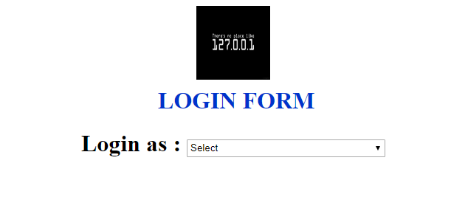

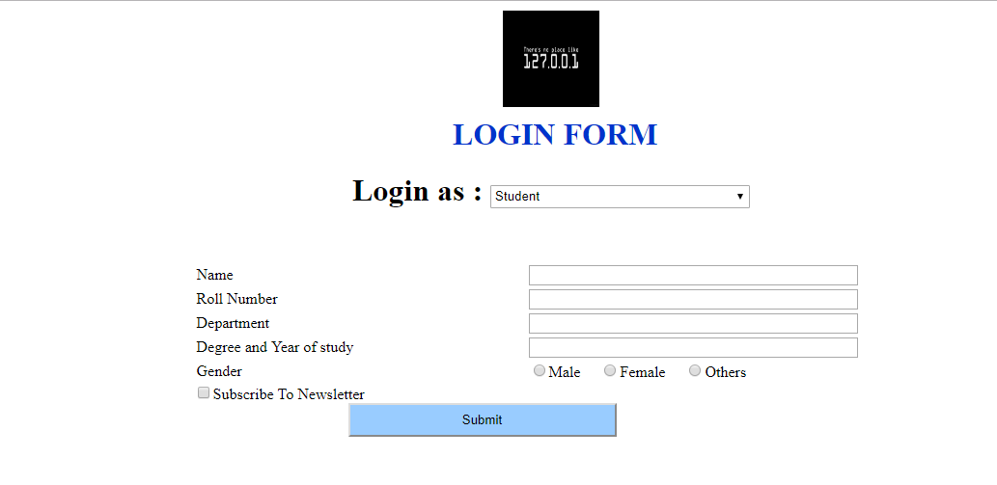

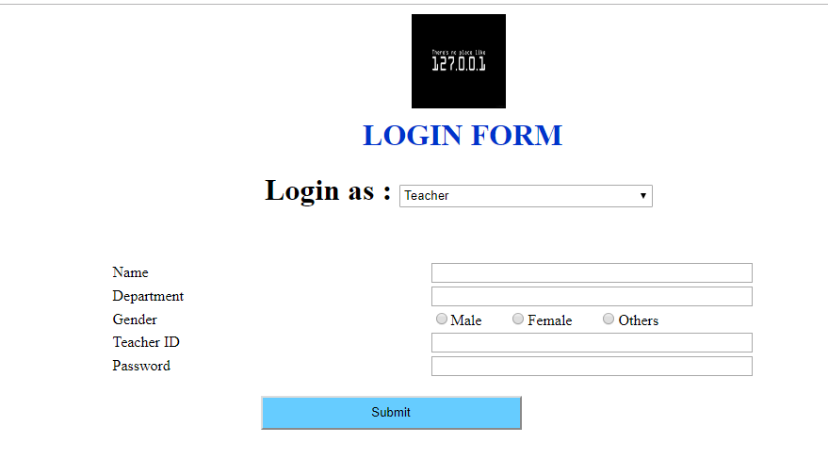

THE LIST CONTROLS

**ASP.NET provides the following list controls.**

* Drop-down list
* List box
* Radio button list
* Check box list
* Bulleted list

These controls display list of options to select. You can select one or more options, the choice depends upon control.

They all derive from the System.Web.UI.WebControls.ListControl class.

## DropDownList control

DropDownList control is used select single option from multiple listed items.

## ListBox control

The ListBox control is similar to the DropDownList but main difference is that you can select multiple items from ListBox at a time. ListBox control has SelectionMode property that enables you to select multiple items from ListBox control. By default SelectionMode property is set as single. If you want to select multiple items from the ListBox, then set SelectionMode property value as Multiple and press Ctrl or Shift key when clicking more than one list item.

## RadioButtonList Control

RadioButtonList Control is same as DropDownList but it displays a list of radio buttons that can be arranged either horizontally or vertically. You can select only one item from the given RadioButtonList of options. These options are mutually exclusive.

## CheckBoxList Control

CheckBoxList is generally used, when you want to select one or more options from given several choices. Most of the properties are same as RadioButtonList control, but the main difference is that you can select more than one item from CheckBoxList control.

## BulletedList Control

BulletedList control is very rich in displaying the items in different styles. It dispalys the list either in unordered or ordered list. Each list item can be rendered as plain text, a LinkButton control, or a link to another web page.  
BulletedList control supports the BulletStyle property. The default value of BulletStyle property is NotSet and rendered as in list of bulleted items.

**SOURCE CODE**

<html xmlns="http://www.w3.org/1999/xhtml">

<head runat="server">

<title></title>

<style type="text/css">

.style1

{

width: 100%;

}

.style2

{

width: 183px;

}

</style>

</head>

<body>

<form id="form1" runat="server">

<div style="text-align:center">

<h1>STUDENT PERFORMA</h1>

</div>

<div >

<asp:Label ID="Label1" runat="server" Text="Select your stream"></asp:Label>

<asp:RadioButtonList ID="RadioButtonList1" runat="server">

<asp:ListItem Value="0">Btech Cse</asp:ListItem>

<asp:ListItem Value="1">Btech Ece</asp:ListItem>

<asp:ListItem Value="2">Btech mech</asp:ListItem>

<asp:ListItem>Btech civil</asp:ListItem>

</asp:RadioButtonList>

<br />

<asp:Label ID="Label2" runat="server" Text="Are you a :"></asp:Label>

<asp:CheckBoxList ID="CheckBoxList1" runat="server">

<asp:ListItem Value="0">Sports Player</asp:ListItem>

<asp:ListItem Value="1">Single girl child</asp:ListItem>

<asp:ListItem Value="2">Resident of J&amp;k</asp:ListItem>

</asp:CheckBoxList>

<br />

<asp:Label ID="Label3" runat="server" Text="Enter mode of education"></asp:Label>

<br />

<asp:ListBox ID="ListBox1" runat="server" Height="21px" Width="354px">

<asp:ListItem Value="0">Distance Education</asp:ListItem>

<asp:ListItem Value="1">Full Time student</asp:ListItem>

<asp:ListItem Value="1">Part time student</asp:ListItem>

</asp:ListBox>

<br />

<br />

<asp:Label ID="Label4" runat="server" Text="Select your institution"></asp:Label>

<br />

<asp:DropDownList ID="DropDownList1" runat="server">

<asp:ListItem Value="0">GNDU RC JAL</asp:ListItem>

<asp:ListItem Value="1">GNDU MAIN CAMPUS</asp:ListItem>

<asp:ListItem Value="2">GNDU RC GURDASPUR</asp:ListItem>

<asp:ListItem Value="3">GNDU RC SATHIALA</asp:ListItem>

</asp:DropDownList>

<br />

<br />

<table cellpadding="2" class="style1">

<tr>

<td class="style2">

Facebook page</td>

<td>

<asp:TextBox ID="TextBox1" runat="server" TextMode="Url" Width="248px"></asp:TextBox>

</td>

</tr>

<tr>

<td class="style2">

linked In</td>

<td>

<asp:TextBox ID="TextBox2" runat="server" TextMode="Url" Width="245px"></asp:TextBox>

</td>

</tr>

<tr>

<td class="style2">

Instagram</td>

<td>

<asp:TextBox ID="TextBox3" runat="server" TextMode="Url" Width="250px"></asp:TextBox>

</td>

</tr>

<tr>

<td class="style2">

Twitter</td>

<td>

<asp:TextBox ID="TextBox4" runat="server" TextMode="Url" Width="251px"></asp:TextBox>

</td>

</tr>

<tr>

<td class="style2">

github</td>

<td>

<asp:TextBox ID="TextBox5" runat="server" TextMode="Url" Width="251px"></asp:TextBox>

</td>

</tr>

</table>

</div>

<div>

<asp:Button ID="Button1" runat="server" Text="Submit" BorderColor="#99CCFF"

style="margin-left: 123px" Width="196px" />

</div>

</form>

</body>

</html>

**OUTPUT :**

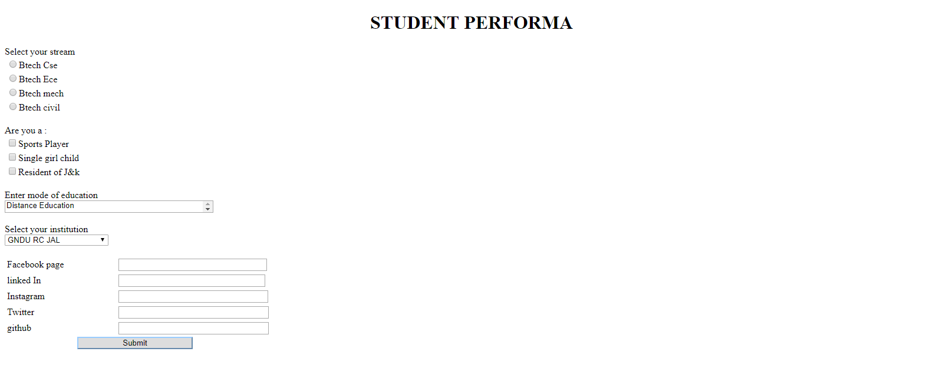

**THE ADVANCE RICH CONTROLS**

ASP.NET provides large set of controls. These controls are divided into different categories, depends upon their functionalities. The followings control comes under the rich controls category.

* FileUpload control
* Calendar control
* AdRotator control
* MultiView control
* Wizard control

#### FileUpload control

FileUpload control is used to browse and upload files. After the file is uploaded, you can store the file on any drive or database. File Upload control is the combination of a browse button and a text box for entering the filename.

#### Calendar control

Calendar control provides you lots of property and events. By using these properties and events you can perform the following task with calendar control.

* Select date.
* Selecting a day, a week or a month.
* Customize the calendar's appearance.

#### AdRotator control

AdRotator control is used to display different advertisements randomly in a page. The list of advertisements is stored in either an XML file or in a database table. Lots of websites uses AdRotator control to display the advertisements on the web page. To create an advertisement list, first add an XML file to your project.

#### MultiView control

MultiView control can be used when you want to create a tabbed page. In many situations, a web form may be very long, and then you can divide a long form into multiple sub forms. MultiView control is made up of multiple view controls. You can put multiple ASP.NET controls inside view controls. One View control is displayed at a time and it is called as the active view. View control does not work separately. It is always used with a Multiview control.

#### Wizard Control

This control is same as MultiView control but the main difference is that, it has inbuilt navigation buttons.The wizard control enables you to design a long form in such a way that you can work in multiple sub form. You can perform the task in a step by step process. It reduces the work of developers to design multiple forms. It enables you to create multi step user interface. Wizard control provides with built-in previous/next functionality.

Source Code

<%@ Page Language="C#" AutoEventWireup="true" CodeFile="teacher.aspx.cs" Inherits="teacher" %>

<!DOCTYPE html PUBLIC "-//W3C//DTD XHTML 1.0 Transitional//EN" "http://www.w3.org/TR/xhtml1/DTD/xhtml1-transitional.dtd">

<html xmlns="http://www.w3.org/1999/xhtml">

<head runat="server">

<title></title>

</head>

<body>

<form id="form1" runat="server">

<div style="text-align:center;">

<h1>ADVERTISEMENTS</h1>

</div>

<div>

<asp:AdRotator ID="AdRotator1" runat="server" DataSourceID="XmlDataSource1" />

<asp:XmlDataSource ID="XmlDataSource1" runat="server" DataFile="~/XMLFile2.xml">

</asp:XmlDataSource>

<asp:AdRotator ID="AdRotator2" runat="server" DataSourceID="XmlDataSource2" />

<asp:XmlDataSource ID="XmlDataSource2" runat="server" DataFile="~/XMLFile2.xml">

</asp:XmlDataSource>

</div>

<div style="margin: 10px auto;">

<asp:Label ID="Label2" runat="server" Text="Name"></asp:Label>

&nbsp;&nbsp;&nbsp;&nbsp;&nbsp;&nbsp;&nbsp;&nbsp;&nbsp;&nbsp;&nbsp;&nbsp;

<asp:TextBox ID="TextBox2" runat="server" Width="125px"></asp:TextBox>

<br />

<asp:Label ID="Label1" runat="server" Text="Date of birth"></asp:Label>

&nbsp;&nbsp;

<asp:TextBox ID="TextBox1" runat="server"></asp:TextBox>

<asp:ImageButton ID="ImageButton1" runat="server" Height="29px"

ImageUrl="~/Images/Capture.PNG" onclick="ImageButton1_Click" Width="30px" />

<br />

<asp:Calendar ID="Calendar1" runat="server" BackColor="White"

BorderColor="White" BorderWidth="1px"

Font-Names="Verdana" Font-Size="9pt" ForeColor="Black" Height="190px"

onselectionchanged="Calendar1_SelectionChanged"

Width="350px" NextPrevFormat="FullMonth">

<DayHeaderStyle Font-Bold="True" Font-Size="8pt" />

<NextPrevStyle Font-Size="8pt" ForeColor="#333333" Font-Bold="True"

VerticalAlign="Bottom" />

<OtherMonthDayStyle ForeColor="#999999" />

<SelectedDayStyle BackColor="#333399" ForeColor="White" />

<TitleStyle BackColor="White" Font-Bold="True" Font-Size="12pt"

ForeColor="#333399" BorderColor="Black" BorderWidth="4px" />

<TodayDayStyle BackColor="#CCCCCC" />

</asp:Calendar>

<br />

<asp:Wizard ID="Wizard1" runat="server" ActiveStepIndex="1" Height="201px"

Width="485px" BackColor="White" BorderColor="Black" BorderStyle="Solid"

ForeColor="#000066">

<WizardSteps>

<asp:WizardStep runat="server" title="Step 1">

<asp:Label ID="Label3" runat="server" Text="ID"></asp:Label>

&nbsp;<asp:TextBox ID="TextBox3" runat="server"></asp:TextBox>

<br />

<asp:Label ID="Label4" runat="server" Text="Phone number"></asp:Label>

&nbsp;<asp:TextBox ID="TextBox4" runat="server"></asp:TextBox>

<br />

Address

<asp:TextBox ID="TextBox5" runat="server"></asp:TextBox>

</asp:WizardStep>

<asp:WizardStep runat="server" title="Step 2">

&nbsp;&nbsp;&nbsp;

<asp:CheckBox ID="CheckBox1" runat="server"

/>

&nbsp;<asp:Label ID="Label5" runat="server" Text="Agree to term and conditions"></asp:Label>

<br />

</asp:WizardStep>

</WizardSteps>

</asp:Wizard>

<br />

</div>

<div>

<asp:Button ID="Button1" runat="server" Text="Submit" />

</div>

</form>

</body>

</html>

**OUTPUT**

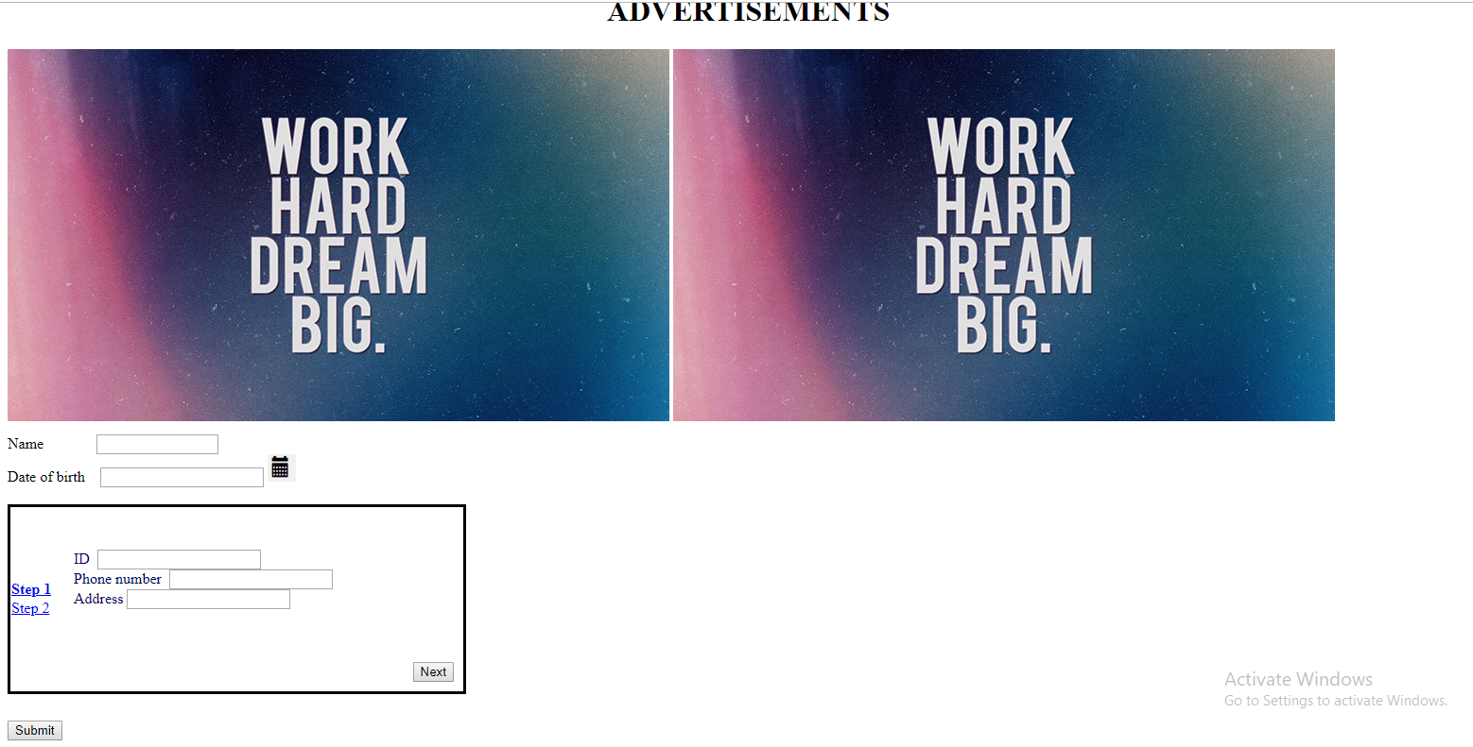

**VALIDATION CONTROLS**

ASP.NET validation controls validate the user input data to ensure that useless, unauthenticated, or contradictory data don't get stored.

ASP.NET provides the following validation controls:

* RequiredFieldValidator
* RangeValidator
* CompareValidator
* RegularExpressionValidator
* CustomValidator
* ValidationSummary

## Required field validator control

The RequiredFieldValidator control ensures that the required field is not empty. It is generally tied to a text box to force input into the text box.

## RangeValidator Control

The RangeValidator control verifies that the input value falls within a predetermined range

## CompareValidator Control

The CompareValidator control compares a value in one control with a fixed value or a value in another control.

## Regular Expression Validator

The RegularExpressionValidator allows validating the input text by matching against a pattern of a regular expression. The regular expression is set in theValidationExpression property.

## Validation Summary

The ValidationSummary control does not perform any validation but shows a summary of all errors in the page. The summary displays the values of the ErrorMessage property of all validation controls that failed validation.

CustomValidator

This control provides the customize validation code to perform both client-side and server-side validation. For example, you can create a validation control that checks whether the value entered into a text box is 8 or more characters long. If none of the other validation controls perform the type of validation that you need, you can always use the CustomValidator control. The control allows you to validate both clientside and serverside, where the serverside approach is probably the most powerful.

Source Code

<%@ Page Language="C#" AutoEventWireup="true" CodeFile="validation.aspx.cs" Inherits="validation" %>

<!DOCTYPE html PUBLIC "-//W3C//DTD XHTML 1.0 Transitional//EN" "http://www.w3.org/TR/xhtml1/DTD/xhtml1-transitional.dtd">

<html xmlns="http://www.w3.org/1999/xhtml">

<head runat="server">

<title></title>

</head>

<body>

<form id="form1" runat="server">

<div>

<asp:Label ID="Label1" runat="server" Text="Name"></asp:Label>

&nbsp;&nbsp;&nbsp;&nbsp;&nbsp;&nbsp;&nbsp;&nbsp;&nbsp;&nbsp;&nbsp;&nbsp;&nbsp;&nbsp;&nbsp;&nbsp;&nbsp;&nbsp;&nbsp;&nbsp;&nbsp;&nbsp;&nbsp;&nbsp;&nbsp;&nbsp;&nbsp;&nbsp;

<asp:TextBox ID="TextBox1" runat="server" style="margin-left: 0px"

Width="267px"></asp:TextBox>

&nbsp;<asp:Label ID="Label8" runat="server" ForeColor="#FF3300" Text="*"></asp:Label>

<asp:RequiredFieldValidator ID="RequiredFieldValidator1" runat="server"

ControlToValidate="TextBox1" ErrorMessage="This is required field"></asp:RequiredFieldValidator>

<br />

<br />

<asp:Label ID="Label3" runat="server" Text="Father's Name"></asp:Label>

&nbsp;&nbsp;&nbsp;&nbsp;&nbsp;&nbsp;&nbsp;&nbsp;&nbsp;&nbsp;&nbsp;&nbsp;&nbsp;&nbsp;&nbsp;

<asp:TextBox ID="TextBox3" runat="server" Width="267px"></asp:TextBox>

<asp:Label ID="Label9" runat="server" ForeColor="#FF3300" Text=" *"></asp:Label>

&nbsp;<asp:RequiredFieldValidator ID="RequiredFieldValidator2" runat="server"

ControlToValidate="TextBox3" ErrorMessage="This is required field"></asp:RequiredFieldValidator>

<br />

<br />

<asp:Label ID="Label4" runat="server" Text="Mother's Name"></asp:Label>

&nbsp;&nbsp;&nbsp;&nbsp;&nbsp;&nbsp;&nbsp;&nbsp;&nbsp;&nbsp;&nbsp;&nbsp;&nbsp;

<asp:TextBox ID="TextBox4" runat="server" style="margin-left: 2px"

Width="266px"></asp:TextBox>

<asp:Label ID="Label10" runat="server" ForeColor="#FF3300" Text=" *"></asp:Label>

<asp:RequiredFieldValidator ID="RequiredFieldValidator3" runat="server"

ControlToValidate="TextBox4" ErrorMessage="This is required field"></asp:RequiredFieldValidator>

<br />

<br />

<asp:Label ID="Label14" runat="server" Text="Current CGPA"></asp:Label>

&nbsp;&nbsp;&nbsp;&nbsp;&nbsp;&nbsp;&nbsp;&nbsp;&nbsp;&nbsp;&nbsp;&nbsp;&nbsp;&nbsp;

<asp:TextBox ID="TextBox8" runat="server" TextMode="Number" Width="264px"></asp:TextBox>

<asp:Label ID="Label15" runat="server" ForeColor="#FF3300" Text=" *"></asp:Label>

&nbsp;<asp:RangeValidator ID="RangeValidator1" runat="server"

ControlToValidate="TextBox8" ErrorMessage="Should be between 4 to 10"

MaximumValue="4" MinimumValue="10"></asp:RangeValidator>

<br />

<br />

<asp:Label ID="Label5" runat="server" Text="Email"></asp:Label>

&nbsp;&nbsp;&nbsp;&nbsp;&nbsp;&nbsp;&nbsp;&nbsp;&nbsp;&nbsp;&nbsp;&nbsp;&nbsp;&nbsp;&nbsp;&nbsp;&nbsp;&nbsp;&nbsp;&nbsp;&nbsp;&nbsp;&nbsp;&nbsp;&nbsp;&nbsp;&nbsp;&nbsp;

<asp:TextBox ID="TextBox5" runat="server" style="margin-left: 3px"

TextMode="Email" Width="268px"></asp:TextBox>

<asp:Label ID="Label12" runat="server" ForeColor="#FF3300" Text=" *"></asp:Label>

<asp:RegularExpressionValidator ID="RegularExpressionValidator1" runat="server"

ControlToValidate="TextBox5" ErrorMessage="Enter correct email address"

ValidationExpression="\w+([-+.']\w+)*@\w+([-.]\w+)*\.\w+([-.]\w+)*"></asp:RegularExpressionValidator>

<br />

<br />

<asp:Label ID="Label6" runat="server" Text="Phone Number"></asp:Label>

&nbsp;&nbsp;&nbsp;&nbsp;&nbsp;&nbsp;&nbsp;&nbsp;&nbsp;&nbsp;&nbsp;&nbsp;&nbsp;

<asp:TextBox ID="TextBox6" runat="server" style="margin-left: 3px"

TextMode="Number" Width="266px"></asp:TextBox>

<asp:Label ID="Label13" runat="server" ForeColor="#FF3300" Text=" *"></asp:Label>

<asp:RequiredFieldValidator ID="RequiredFieldValidator5" runat="server"

ControlToValidate="TextBox6" ErrorMessage="This is required field"></asp:RequiredFieldValidator>

<asp:CustomValidator ID="CustomValidator1" runat="server"

ControlToValidate="TextBox6" ErrorMessage="minimum 10 numbers"></asp:CustomValidator>

<br />

<br />

<br />

<asp:Label ID="Label7" runat="server" Text="Address"></asp:Label>

&nbsp;&nbsp;&nbsp;&nbsp;&nbsp;&nbsp;&nbsp;&nbsp;&nbsp;&nbsp;&nbsp;&nbsp;&nbsp;&nbsp;&nbsp;&nbsp;&nbsp;&nbsp;&nbsp;&nbsp;&nbsp;&nbsp;&nbsp;

<asp:TextBox ID="TextBox7" runat="server" style="margin-left: 6px"

TextMode="MultiLine" Width="264px"></asp:TextBox>

<asp:Label ID="Label11" runat="server" ForeColor="#FF3300" Text=" *"></asp:Label>

<asp:RequiredFieldValidator ID="RequiredFieldValidator6" runat="server"

ControlToValidate="TextBox7" ErrorMessage="This is required field"></asp:RequiredFieldValidator>

<br />

<br />

<asp:Label ID="Label16" runat="server" Text="Enter password"></asp:Label>

&nbsp;&nbsp;&nbsp;&nbsp;&nbsp;&nbsp;&nbsp;&nbsp;&nbsp;&nbsp;&nbsp;&nbsp;&nbsp;

<asp:TextBox ID="TextBox9" runat="server" style="margin-left: 3px"

TextMode="Password" Width="268px"></asp:TextBox>

<br />

<br />

<asp:Label ID="Label17" runat="server" Text="Renter password"></asp:Label>

&nbsp;&nbsp;&nbsp;&nbsp;&nbsp;&nbsp;&nbsp;&nbsp;&nbsp;&nbsp;&nbsp;

<asp:TextBox ID="TextBox10" runat="server" style="margin-left: 3px"

TextMode="Password" Width="268px"></asp:TextBox>

<asp:CompareValidator ID="CompareValidator1" runat="server"

ControlToCompare="TextBox9" ControlToValidate="TextBox10"

ErrorMessage="Entered password does not match"></asp:CompareValidator>

<br />

<br />

<asp:Button ID="Button1" runat="server" BackColor="#99CCFF"

style="margin-left: 80px" Text="Submit" Width="181px" />

<br />

</div>

</form>

</body>

</html>

Output

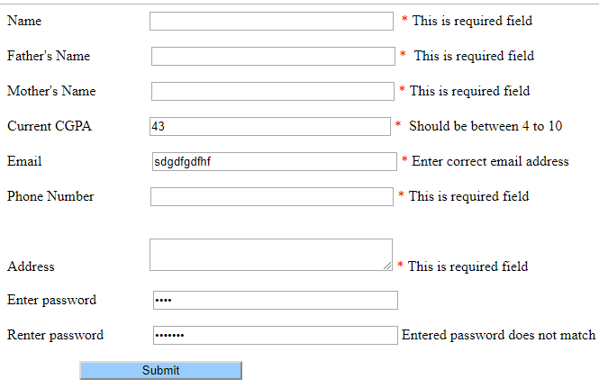

DATA BOUND CONTROLS

ASP.NET provides a wide variety of rich controls that can be bound to data. Under the Data tab of the Visual Studio Toolbox, you can get several controls under the Data tab that could be used to display data from a data source, like a database or XML file.

The standard ASP.NET data presentation controls are:

* DataList
* DetailsView
* FormView
* GridView
* ListView
* Repeater